**DAILY ONLINE ACTIVITIES SUMMARY**

|  |  |  |  |  |  |  |  |
| --- | --- | --- | --- | --- | --- | --- | --- |
| **Date:** | **28/05/2020** | | | | **Name:** | **Sheetal** | |
| **Sem & Sec** | **8 B** | | | | **USN:** | **4AL16CS091** | |
| **Online Test Summary** | | | | | | | |
| **Subject** | | **SMS** | | | | | |
| **Max. Marks** | | **60** | | **Score** | | **57** | |
| **Certification Course Summary(Internship)** | | | | | | | |
| **Task** | **Study-Learning data analytics concepts with platform specified**  **POC- working on development of custom visual for the dashboard using typescript language with nodejs D3.js** | | | | | | |
| **company** | | | **Gain-insights** | **Duration** | | | **8 hr** |
| **Coding Challenges** | | | | | | | |
| **Problem Statement:**  **1) write a python program to convert celsius to fahrenheit** | | | | | | | |
| **Status:completed** | | | | | | | |
| **Uploaded the report in Github** | | | | **Yes** | | | |
| **If yes Repository name** | | | | [alvas-education-foundation](https://github.com/alvas-education-foundation)/ **[sheetal-shettigar](https://github.com/alvas-education-foundation/sheetal-shettigar)** | | | |
| **Uploaded the report in slack** | | | | **Yes** | | | |

ONLINE TEST: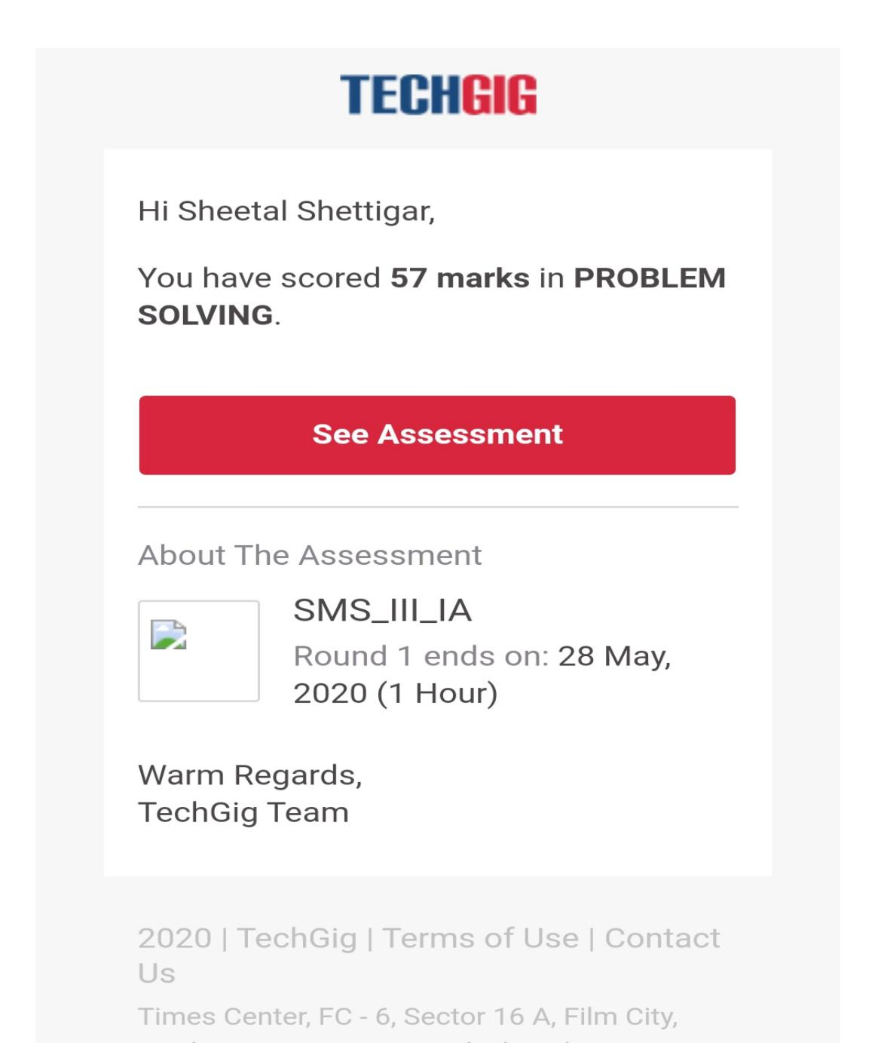

CODING CHALLENGE:

PROGRAM 1 :

Celsius=37.5

Fahreheit=(celsius*1.8)+32

Print(‘%0.IfdegreeCelsiusisequalto%0.IfdegreeFahrenheit’%(Celsius,Fahrenheit))